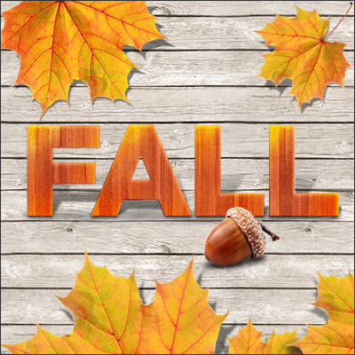
Join us for a fun event! Get tips and tricks to get your child to love reading!
Candy, punch, door prizes and books!
October 25th
Central Primary Cafeteria and Library
5:00-6:30 pm
- Fall Leaves
- The Great Pumpkin
- Poem Books
- Scattegories
- Bilingual Loteria/Spanish Reading Books
- Popcorn Words & Zingo
- Go Away Big Green Monster
- Fall Maze
- Scholastic Book Fair

